Activity 13.1

1. A screenshot of a computer

   Description automatically generated
   1. Screenshot of my code to make a mysql docker.
2. Text

   Description automatically generated
   1. Ran the container file and passed -create to make a new mysql docker
3. Graphical user interface, text, application

   Description automatically generated
   1. Docker desktop with the mysql running
4. 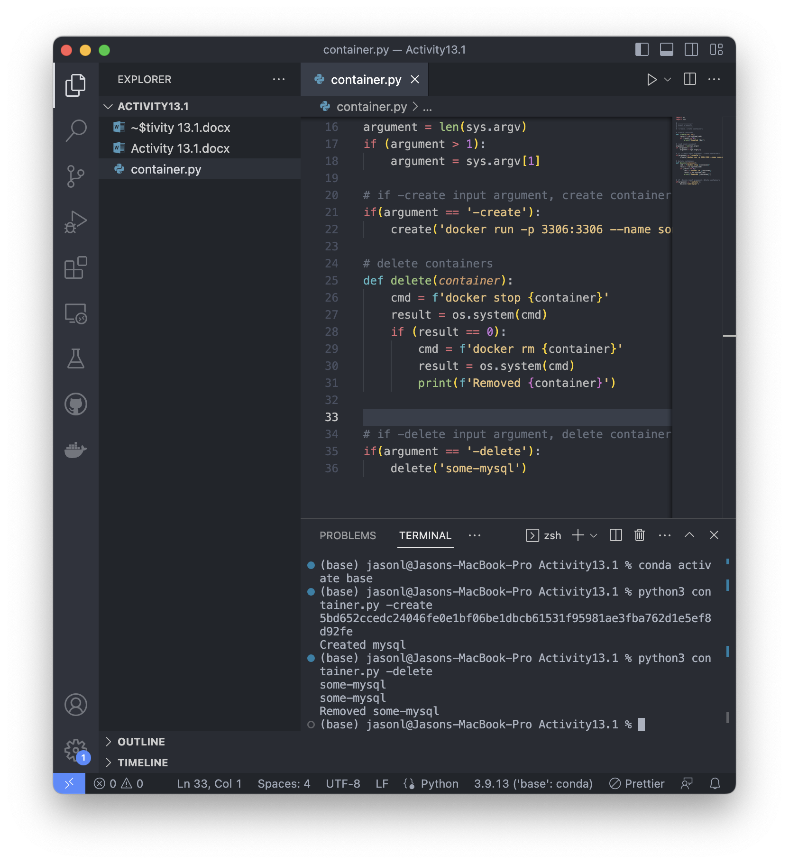
   1. It shows that the docker was deleted
5. Graphical user interface, application

   Description automatically generated
   1. Screenshot of a blank docker desktop showing that he previous mysql container was deleted.
6. Text

   Description automatically generated
   1. Screenshot with code that includes the ability to create all databases together.
7. Text

   Description automatically generated
   1. Screenshot showing all of the databases were created successfully
8. Graphical user interface, text, application

   Description automatically generated
   1. Databases were all created and are running in docker desktop.
9. Graphical user interface, text

   Description automatically generated
   1. Code after adding all of the delete functions for each of the database types.
10. Graphical user interface, text

    Description automatically generated
    1. Successfully ran the code and deleted all of the databases created before.
11. Graphical user interface, application

    Description automatically generated
    1. Screenshot of docker desktop showing I deleted all of the previous containers.